TWO PLUS TWO (Edits to Existing) – Need proof and estimate for 5,000
FORMER DESIGN:
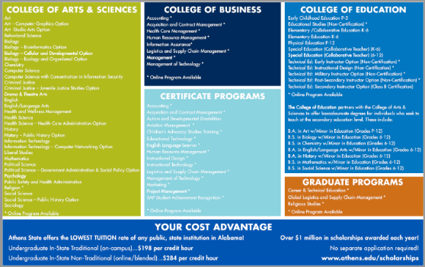

CHANGE FRONT COMPLETELY…something comparable to:
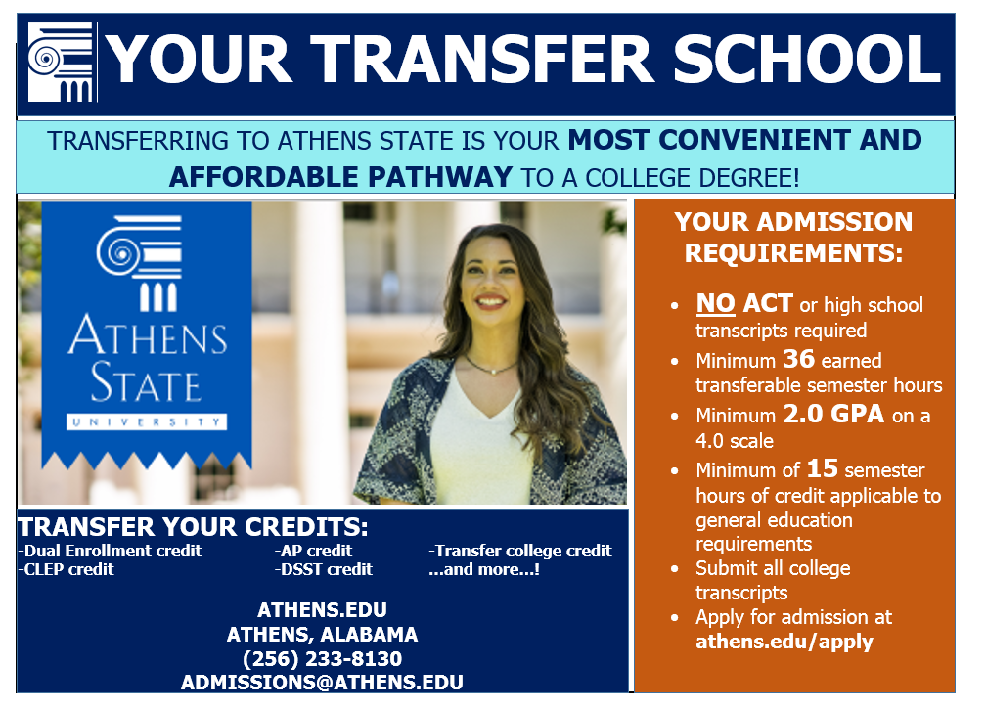
- Front: Change Header of TWO PLUS TWO to YOUR TRANSFER SCHOOL
- Front: Change Tagline to: Transferring to Athens State is your most convenient and affordable pathway to a college degree. (Or something similar)
- Front: Update photo design
- Front: Add Your Admission Requirements section
-No ACT or SAT score required
-No high school transcripts required
-Minimum 36 earned transferable semester hours
-Minimum 2.0 GPA on a 4.0 scale
-Minimum of 15 semester hours of general education requirements complete
-Submit all official college transcripts
-Apply for admission at Athens.edu/apply
- Front: Add Transfer Your Credits section
-Dual Enrollment credit
-AP credit
-Transfer college credit
-CLEP credit
-DSST credit
-And more!
- Front: Add map with star next to contact info if possible
- Back: Update programs (see next page)
- Back: Under Your Cost Advantage: Change to
Undergraduate In-State traditional (on-campus)…$6,168 per year
Undergraduate Out-of-State traditional…$11,112 per year
Undergraduate Non-traditional (online/blended)…$7,128 per year
*Based on total tuition and fees for academic year of two semesters or 24 undergraduate hours

COLLEGE OF ARTS & SCIENCES (* indicates Teacher Certification Option Available and + indicates online program option)

Art*
Art – Computer Graphics Option
Art – Studio Arts Option
Behavioral Science
Biology*
Biology – Bioinformatics Option
Biology – Cellular & Developmental Option
Biology – Ecology & Organismal Option
Chemistry*
Computer Science
Computer Science with Concentration in Information Security
Criminal Justice
Criminal Justice – Juvenile Justice Studies Option
Drama & Theatre Arts
English
English/Language Arts*
Health & Wellness Management
Health Science
Health Science – Health Care Administration Option
History*
History – Public History Option
Information Technology
Information Technology – Computer Networking Option
Liberal Studies
Mathematics*
Political Science
Political Science – Government Administration & Social Policy Option
Psychology
Public Safety & Health Administration
Religion+
Social Science*
Social Science – Public History Option
Sociology

COLLEGE OF BUSINESS (+ indicates online program option)

Accounting+
Acquisition & Contract Management+
Health Care Management+
Human Resource Management+
Information Assurance+
Logistics & Supply Chain Management+
Management+
Management of Technology+

COLLEGE OF EDUCATION (+ indicates online program option)

Early Childhood Education P-3
Educational Studies (Non-Certification)+
Elementary/Collaborative Education K-6
Elementary Education K-6
Physical Education P-12
Special Education (Collaborative Teacher) K-6
Special Education (Collaborative Teacher) 6-12
Technical Education: Early Instructor Option (Non-Certification)+
Technical Education: Instructional Design (Non-Certification)+
Technical Education: Military Instructor Option (Non-Certification)+
Technical Education: Post-Secondary Instructor Option (Non-Certification)+
Technical Education: Secondary Instructor Option (Class B Certification)

CERTIFICATE PROGRAMS (+ indicates online program option)

Accounting+
Acquisition & Contract Management+
Autism & Developmental Disabilities+
Aviation Management+
Children’s Advocacy Studies Training+
Cybersecurity Operations+
Educational Technology+
English Language Learner+
Human Resource Management+
Information Security+
Instructional Design+
Instructional Technology+
Logistics & Supply Chain Management+
Management of Technology+
Marketing+
Project Management+
SAP Student Achievement Recognition+

GRADUATE PROGRAMS (+ indicates online program option)

Career & Technical Education+
Global Logistics & Supply Chain Management+
Religious Studies+

