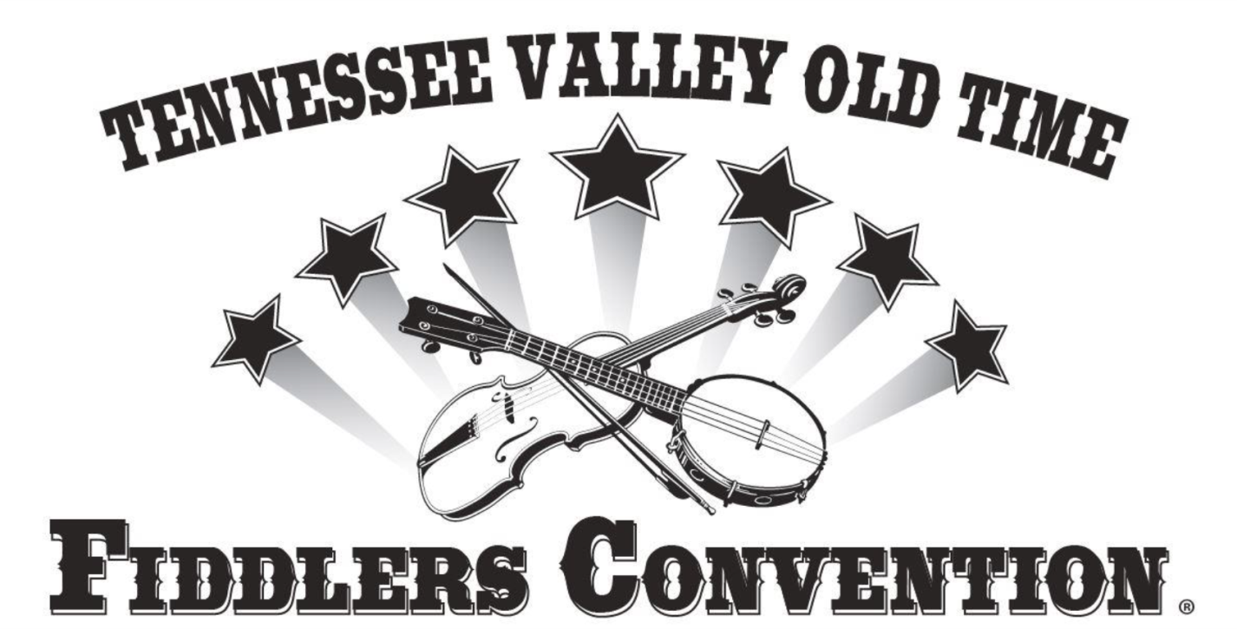

2018 Contests & Prizes
$18,225 Total Cash Prizes
$1,200 Cash Prize plus Trophy to Top Fiddler

FRIDAY, OCTOBER 5, 2018
REGISTRATION: Begins at 12:00 Noon

COMPETITIONS HELD ON
ALABAMA FARMERS COOPERATIVE MAIN STAGE at FOUNDERS HALL
Beginning at 7:00 PM

 | 1st | 2nd | 3rd | 4th | 5th
Harmonica (Finals) | $200 | $125 | $75 | $50 | $25
Mandolin (Finals) | $200 | $125 | $75 | $50 | $25
Bluegrass Banjo (Finals) | $200 | $125 | $75 | $50 | $25
Dobro (Finals) | $200 | $125 | $75 | $50 | $25
Dulcimer (Finals) | $200 | $125 | $75 | $50 | $25

COMPETITIONS HELD ON
McCANDLESS HALL STAGE
Beginning at 8:00 PM
 | 1st | 2nd | 3rd | 4th | 5th
Old Time Singing (Finals) | $200 | $125 | $75 | $50 | $25

SATURDAY, OCTOBER 6, 2018
7:45 AM REGISTRATION: Beginning Fiddler, Beginner Musician & Guitar Finger Picking
8:30 AM REGISTRATION: All other competitions; Ends 30 minutes prior to each category competition

COMPETITIONS HELD ON
AETOS SYSTEMS STAGE at BROWN HALL
Beginning at 8:30 AM

 | 1st | 2nd | 3rd | 4th | 5th
Beginning Fiddler (10 & Under) (Finals) | $200 | $125 | $75 | $50 | $25
Apprentice Fiddler (11-15) (Finals) | $300 | $200 | $100 | $75 | $50
Beginner Musician - Guitar, Banjo, or Mandolin (Finals) | $200 | $125 | $75 | $50 | $25

COMPETITIONS HELD ON
ALABAMA FARMERS COOPERATIVE MAIN STAGE at FOUNDERS HALL
Beginning at 8:30 AM
 | 1st | 2nd | 3rd | 4th | 5th
Guitar Finger Picking (Finals) | $200 | $125 | $75 | $50 | $25
Old Time Banjo (Finals) | $200 | $125 | $75 | $50 | $25
Classic Old-Time Fiddler | $600 | $400 | $300 | $200 | $100
Guitar Flat Picking (Finals) | $200 | $125 | $75 | $50 | $25
Senior Fiddler (55+) | $600 | $400 | $300 | $200 | $100
Bluegrass Band | $1000 | $500 | $300 | $200 | $100
Junior Fiddler (16-34) | $600 | $400 | $300 | $200 | $100
Old Time String Band | $1000 | $500 | $300 | $200 | $100
Intermediate Fiddler (35-54) | $600 | $400 | $300 | $200 | $100
Fiddle Off | $600 | $400 | $200

COMPETITIONS HELD ON
AETOS SYSTEMS STAGE at BROWN HALL
Beginning at 2:00 PM

 | 1st | 2nd | 3rd | 4th | 5th
Buck Dancing | $200 | $125 | $75 | $50 | $25

SATURDAY, OCTOBER 6, 2018
FINALS HELD ON
ALABAMA FARMERS COOPERATIVE MAIN STAGE at FOUNDERS HALL
Beginning at 7:30 PM
Senior Fiddler
Classic Old-Time Fiddler
Bluegrass Band
Junior Fiddler
Old Time String Band
Intermediate Fiddler
Buck Dancing
Fiddle-Off

